­

Project Design Phase-II Technology Stack (Architecture & Stack)

|  |  |
| --- | --- |
| Date | 01 November 2023 |
| Team Leader | M. Akash |
| Project Name | Online Payments Fraud Detection Using Machine Learning |

Technical Architecture:

The Deliverable shall include the architectural diagram as below and the information as per the table1 & table 2

Example: Order processing during pandemics for offline mode

Reference: <https://developer.ibm.com/patterns/ai-powered-backend-system-for-order-processing-during-pandemics/>

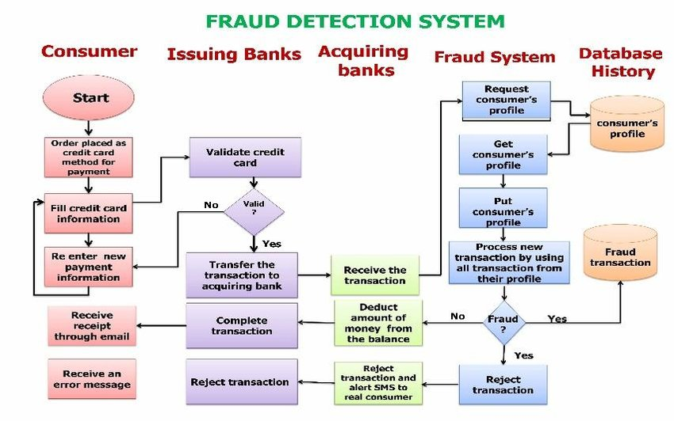

Guidelines:

1. Include all the processes (As an application logic / Technology Block)
2. Provide infrastructural demarcation (Local / Cloud)
3. Indicate external interfaces (third party API’s etc.)
4. Indicate Data Storage components / services
5. Indicate interface to machine learning models (if applicable)

Table-1 : Components & Technologies:

|  |  |  |  |
| --- | --- | --- | --- |
| **S.No** | **Component** | **Description** | **Technology** |
| 1. | Data Ingestion | Collects transaction data from various sources | Data Pipeline |
| 2. | Data Storage | Stores transaction data for analysis | Relational Database |
| 3. | Data Preprocessing | Cleaning and preparing data for analysis | Python, Pandas, NumPy |
| 4. | Machine Learning Model | Building the fraud detection model | Python, Scikit-Learn, TensorFlow |
| 5. | Model Serving | Serves trained ML models for real-time prediction | Kubernetes |
| 6. | Model Training | Training the ML Model | Python, Scikit-Learn, TensorFlow |
| 7. | Model Evaluation | Evaluating model performance | Python, Scikit-Learn |
| 8. | Real-time Monitoring | Monitors transactions for suspicious activity | Stream Processing |
| 9. | Alerting System | Sends alerts on potential fraud | Email, SMS |
| 10. | User Interface | Provides a dashboard for users and administrators | Web Application (HTML, CSS, JavaScript) |
| 11. | Reporting | Generates reports and analytics | BI Tools (e.g., Tableau, Power BI) |

Table-2: Application Characteristics:

|  |  |  |  |
| --- | --- | --- | --- |
| **S.No** | **Characteristics** | **Description** | **Technology** |
| 1. | Scalability | The system should scale to handle a large volume of transactions | Horizontal scaling, load balancing |
| 2. | Real-time Processing | The system needs to process transactions in real-time | Stream processing, event-driven architecture |
| 3. | Model Training | The system should continuously retrain machine learning models | Automated pipeline with scheduling |

|  |  |  |  |
| --- | --- | --- | --- |
| **S.No** | **Characteristics** | **Description** | **Technology** |
| 4. | Security | Robust security measures to protect against fraudulent activities | Encryption, authentication, authorization |
| 5. | Monitoring | Comprehensive monitoring to detect system anomalies | Logging, monitoring tools |
| 6. | User-Friendly Interface | An intuitive interface for users and administrators | Responsive web design, UX/UI best practices |
| 7. | Reporting & Analytics | Advanced reporting and analytics for decision-making | BI tools and data visualization libraries |